###### 

###### **FOR THE RECORD**

**MESSAGE FROM PRESIDENT, TRENT FRASER, and**

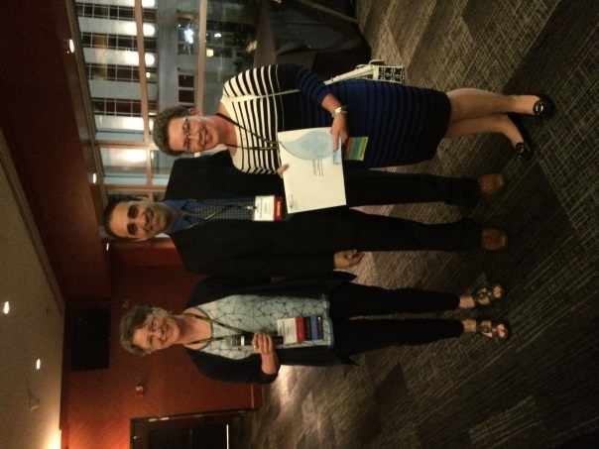**EXECUTIVE DIRECTOR, SHEILA KELLY**

We always knew that we were right! This does sound presumptuous, but now we have the hardware to prove it. Trent’s message in the last edition of *For The Record* spoke to the continuous improvements we have been making as an organization. Included on the list was our new responsive website which, to quote Trent, leads the nation amongst provincial sports hall of fames. This comment was substantiated and then some when [www.sasksportshalloffame.com](http://www.sasksportshalloffame.com) was awarded an “ISHY” by the International Sports Heritage Association (ISHA) for best in the industry for institutions with a budget greater than $250K US. The ISHY trophy was presented as part of the 2014 Communication Awards at ISHA’s annual conference hosted this year by the Tennessee Sports Hall of Fame at the Bridgestone Arena in Nashville, TN and is now proudly displayed (next to our 2010 award) in the SSHF. We, in turn, wish to recognize our web designers, Command Base Creative Design, for their work on this award winning initiative.

*Photo: Paula Homan (ISHA Communications Award Chair), Saleem Chadry (ISHA Communications Award Vice Chair), and Sheila Kelly at the awards presentation*

The SSHF has had a number of other successes over the past few months. First up was a board/staff retreat hosted in Waskesiu on the September 20/21 weekend. This was an opportunity to continue the strategic review process for the next three years, reaffirm our organizational priorities, and confirm our strategic goals – paramount of these being a redeveloped Hall.

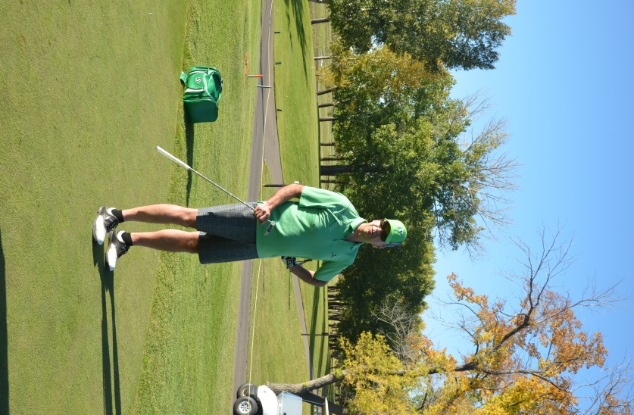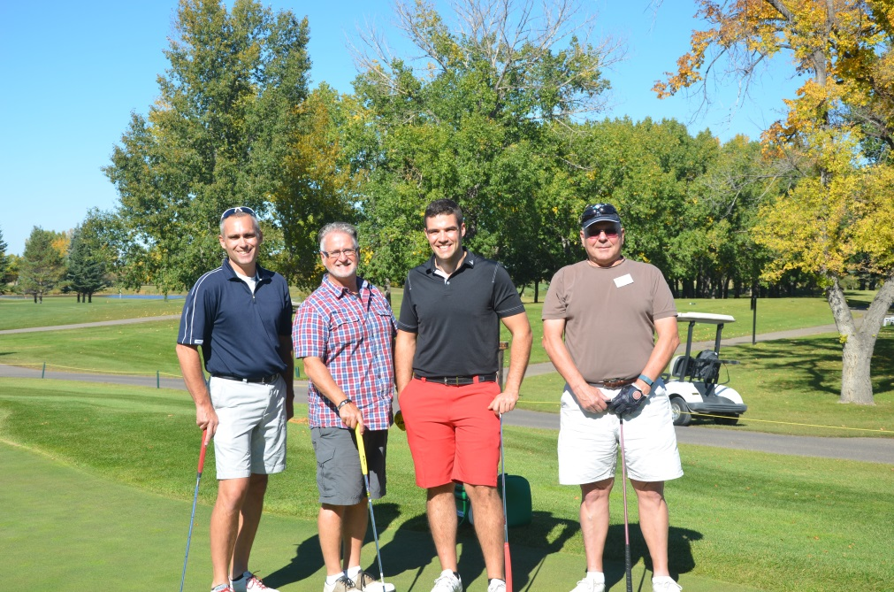We left Waskesiu primed for action and immediately headed to Saskatoon where we were once again thrilled to partner with the Saskatchewan Roughrider Alumni Association for their 2nd Annual Autumn Golf Classic. The timing couldn’t have been better for us as the tournament was hosted at the Saskatoon Golf & Country Club on September 22 ensuring that many of our board members could get involved as a natural extension of our retreat. What a fabulous event this tournament was. Thank you to the golfers and corporate sponsors who chose to support this event so strongly. We know that the golf tournament roster can be crowded so we very much appreciate your decision to support this one. We would also like to thank the many volunteers who worked in support of this tournament both on and off the course. It would not have been the success it was without you!

**November/December, 2014**

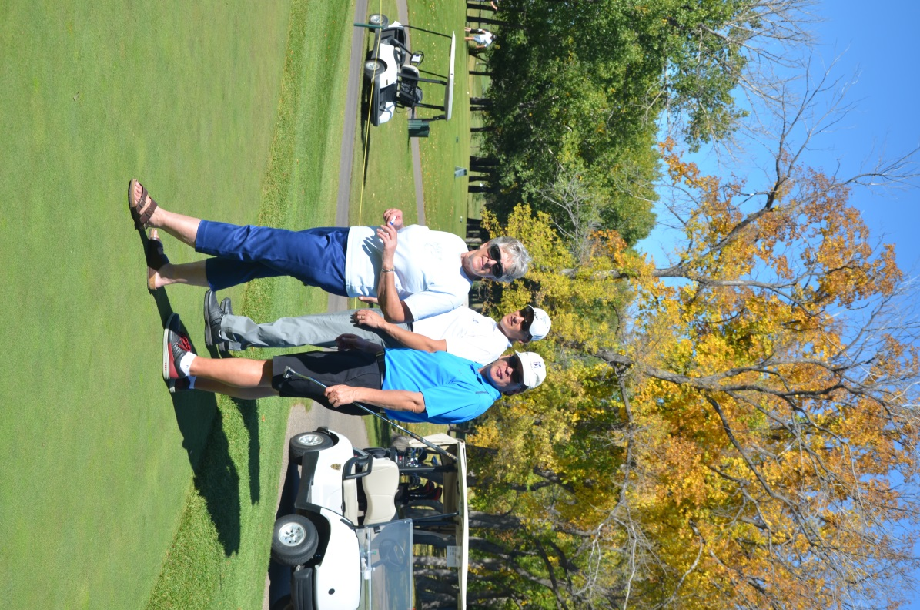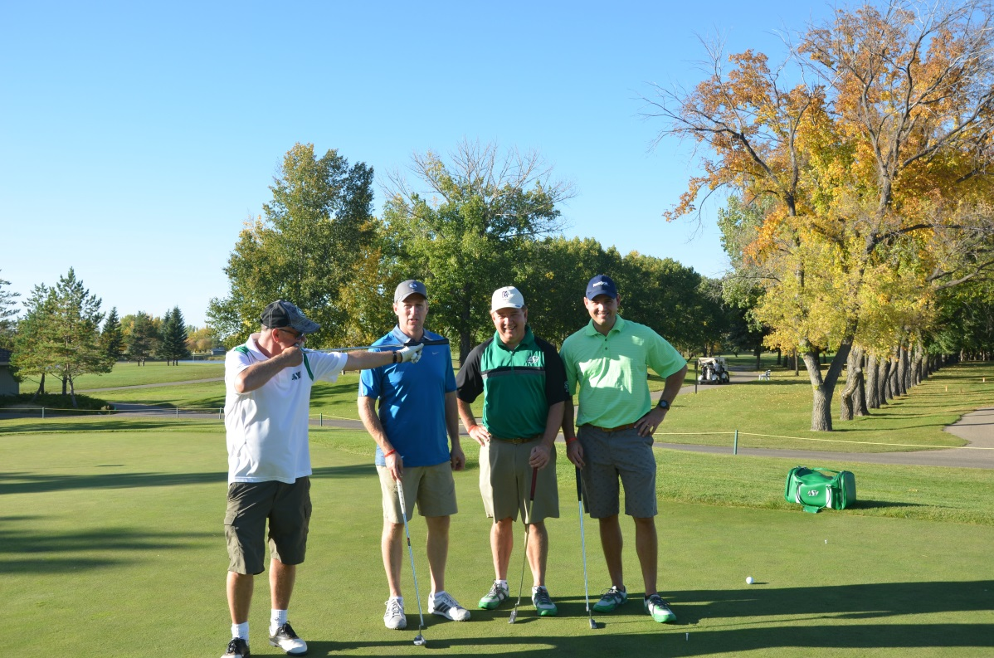

*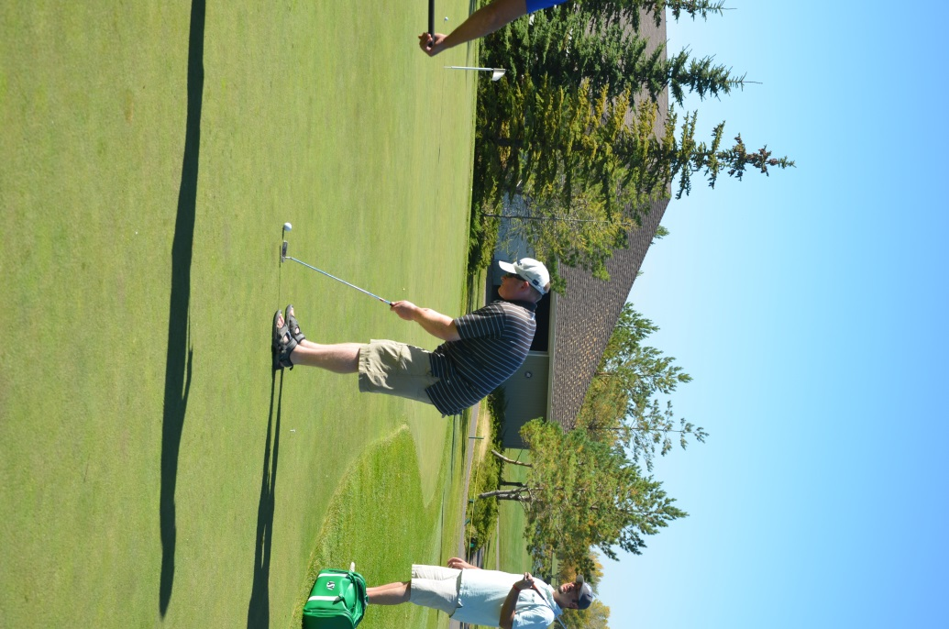Photos: (Above - Left to Right: Craig Peterson, Curtis Gulka, Hugh Vassos-SSHF Past President, and Jaysen Hustej; Scott Waters-SSHF Vice President; Shirley Kowalski-SSHF inductee, Zane Hansen-SIGA President & CEO, and Vance McNab-SSHF Director*

*Photos: (Previous Page - Left to Right: Fred Dyck, Saskatchewan Triathlon Association, Trent Fraser-SSHF President, Rankin Jaworksi and Donald Gall – SSHF Directors; Steve Chisholm – SSHF Director*

One of the deciding factors in the SSHF winning the aforementioned ISHY is the amount of traffic and public interest that our website is generating. Our Google Analytic results are, to be honest, quite extraordinary. We see hundreds of visitors checking out our site every month. And they aren’t simply parachuting in for a quick fact check. They are spending some serious time with an average 12 minutes per visit. Our “bounce rate” (leaving the website from the landing page without browsing anywhere else on the site) is 3%. This is “off the charts” better than the accepted industry “norm” which sees visitors to most websites bounce off the landing page at a rate of 60-70%. What is driving this level of interest? We believe it has a lot to do with the quality content that we are working hard to continually add to the site. Among the latest content additions are our Saskatchewan and the Grey Cup vignettes which premiered in the SSHF on November 19, 2013. Previously only viewable within the SSHF galleries, *Saskatchewan and the Grey Cup - Hope and Heartbreak*, *Saskatchewan and the Grey Cup - The Winning Years*, and *Saskatchewan and the Grey Cup: A Community Embrace* can now also be viewed online at <http://sasksportshalloffame.com/saskatchewan-grey-cup-vignettes>. The Class of 2014 inductee vignettes are also available for viewing on our website. For easy access simply search “2014” on the homepage, or enter any of the names of this year’s class: Abbott, Bourne, Lavallee, Magnuson, Clark, Petit, 1996 Randy Bryden Curling and 2001, 2002 or 2003 Saskatoon Hilltops. We also continue to add previous year’s inductee videos, as well as components of our artifact collection. Check back often to see what the newest additions are.



On November 4 we had the pleasure of hosting our President’s Reception in Saskatoon at The Willows. This reception offered our board and staff a wonderful opportunity to catch up with past inductees and SSHF members, provide them with an overview of what we have been up to for the past year, unveil our ISHY award trophy, and share information on our new and ongoing programming initiatives. We look forward to hosting the Regina President’s Reception on December 6.

The Angus Reid Institute recently released conducted a survey that revealed Saskatchewan’s interest in sports rates the highest in the country……especially when it comes to football. Really?!! They needed to conduct a survey to figure that out? Here at the SSHF we aim to cover off all of the interests of the sports fans in your family. As we enter into the holiday season we encourage you to make a visit to the SSHF part of your family plans and take in the diverse exhibits currently on display. *Out of the Vault and Out of the Ordinary* showcases a number of rarely seen themes from the extensive permanent collection. *Dedication to Sport: Our Newest Inductees* provides an in-depth look at each of the 2014 inductees. And, of course, there is the Honoured Members Gallery which features each of our 498 inductees. Like we said there’s something for everyone.

On behalf of the Saskatchewan Sports Hall of Fame Board of Directors and staff, we would like to take this opportunity to wish you all Happy Holidays and a Happy New Year. We look forward to seeing you in 2015.

*Photo: (Above) President’s Reception, Saskatoon)*

**MEMBERSHIP RATES SET TO INCREASE**

The 2015 annual membership campaign will be launched in mid-January. At that time, after more than 10 years of holding the cost, we will be implementing an increase to our membership rates. The new pricing will be:

* $35 Individual
* $50 Family
* $60 PSGB
* $100 Corporate

Membership benefits have been expanded over the past few years to now include:

* Unlimited free admission to the SSHF
* Weekly “What’s On” eBlast (to those who provide an email address)
* *For The Record*, our quarterly news publication circulated electronically or in print based on your preference
* Invitations to exhibit openings and other special events at the SSHF
* 10% discount or “Member Pricing” on special and fundraising events (some exceptions apply)
* Voting privileges at the Annual General Meeting

To maximize all of the benefits of membership please ensure that we have up-to-date contact information for you. Additionally, to keep in contact with us and the many programs and events we are implementing please visit our award winning website at [www.sasksportshalloffame.com](http://www.sasksportshalloffame.com); our Facebook page at SaskSportsHF; or join us on our Twitter account @SaskSportsHF.

**SPORTS INVESTORS CLUB – TEAMMATE PROGRAM**

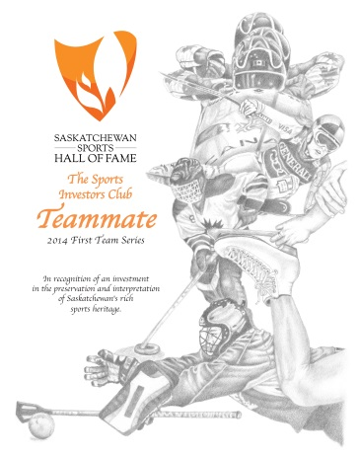The Saskatchewan Sports Hall of Fame invites you to invest in the preservation and interpretation of Saskatchewan’s rich sports heritage through our dedicated fund raising program, the Sports Investors Club. Now in its third year, individual Teammate purchases of $500 have raised over $35,000 in support of the implementation of our strategic operations plan. Your commitment to this program not only supports annual operational priorities, it also supports our long term development plans. $50 from your donation will be allocated to the Sports Legacy Fund (SLF) to support our plans for facility and exhibit upgrades.

Benefits associated with the Teammate recognition include:

• Exclusive commemorative 2014 Teammate certificate (sample to the right)

• Invitation to the annual President’s Reception (event hosted in Regina & Saskatoon)

• Recognition on the SSHF website as a Teammate

• Membership benefits in the SSHF for one year

o For The Record, our quarterly news publication emailed to you

o Invitations to exhibit openings and other special events at the SSHF

o 10% discount or “Member Pricing” on special and fundraising events

o Voting privileges at the Annual General Meeting

• Tax receipt for $450 issued through the SSHF

• Tax receipt for $50 issued through the Sport Legacy Fund on behalf of the SSHF (an additional 20% is receipted when the donor is an individual)

We are excited to bring the Sport Legacy Fund contribution of 10% from all Sport Investor Club purchases into the program. By doing so we are able to benefit from a 20% top up of these funds through Saskatchewan Lotteries**\***. These funds do get locked in for a period of 5 years and will become a foundation of our redevelopment initiatives as we work to establish a new home for the SSHF.

Please contact Sheila Kelly, Executive Director, at 306-780-9233or skelly@sshfm.com should you wish to purchase a Teammate or have any additional questions about the Sports Investors Club Program.

**\***Top up does not apply to corporate donations

**IN MEMORIAM**

The members of the Board and staff extend their sincere sympathies to the family and friends of Richard and Ken.

**Richard Uhrich** passed away on September 4, 2014 at the age of 60. Rick was a member of the 1974 Regina Pats who won the Memorial Cup. Rick and his teammates were inducted into the Saskatchewan Sports Hall of Fame in 1980.

**Ken Reed**, a member of the 1966 Grey Cup winning Saskatchewan Roughriders, passed away on September 4, 2014 at the age of 72. Ken played with the Riders from 1965–1970, being named a West All-Star in 1969. Ken and his 1966 teammates were inducted into the Saskatchewan Sports Hall of Fame in 1967.

**INDUCTEE NOTES**

Congratulations are extended to the following honoured members of the SSHF on their most recent accomplishments.

**George Reed** received the Saskatchewan African Canadian Heritage Museum Lifetime Achievement Award of Excellence on September 13, 2014, for his “outstanding leadership, commitment and service to and for the people of Saskatchewan.”

**George Reed** was recognized as the Outstanding Philanthropist by the Association of Fundraising Professionals on November 12, 2014. George received his recognition in conjunction with National Philanthropy Day.

The **1974 Regina Pats** celebrated the 40th anniversary of their Memorial Cup win with a ceremony in Regina on October 10, 2014. The team included Bill Bell, Glen Burdon, Drew Callander, Dave Faulkner, **Clark Gillies,** Jon Hammond, Mike Harazny, Greg Joly, Rob Laird, Bob Leslie, Kim MacDougall, Jim Minor, Dennis Sobchuk, **Ed Staniowski,** Dave Thomas, Rob Tudor, Rick Uhrich, Mike Wanchuk and Mike Wirachowsky on the ice; **Bob Turner** (coach) behind the bench; and Norm Fong (trainer), Wayne Zurowski (asst. trainer), Dr. Jim Chatwin (physician), **Del Wilson** (general manager) and John Weber (asst. manager) in the wings. (*Team members who are also individual SSHF inductees are recognized in bold*).

**2014/2015 BOARD OF DIRECTORS**

President Trent Fraser Directors Steve Chisholm Donald Gallo

Vice President Scott Waters Laurel Garven Rankin Jaworski

Treasurer Justin E. Scott Greg Indzeoski Vance McNab

Secretary Linda Burnham Nathan Morrison Paul Spasoff

Past President Hugh Vassos

**STAFF**

Executive Director Sheila Kelly

Curator Brock Gerrard

Online Programmer Tyler Daku

Office Assistant Vickie Krauss

**GENERAL INFORMATION**

Saskatchewan Sports Hall of Fame e-mail: sshfm@sasktel.net

2205 Victoria Avenue Web Site: www.sasksportshalloffame.com

Regina, Saskatchewan Telephone: (306) 780-9232

S4P 0S4 Fax: (306) 780-9427

Twitter: @SaskSportsHF

[Facebook: www.facebook.com/SaskSportsHF](http://Facebook:%20%09www.facebook.com/SaskSportsHF)

Monday to Friday 9:00 am - 5:00 pm

Saturday (May 17 – August 30, 2014) Noon – 5:00 pm

Please call the office or check our website for updates on holiday hours in December and January.

**PHOTO CREDITS**

ISHY Award Presentation – Courtesy of the International Sports Heritage Association

All other photographs – Courtesy of the Saskatchewan Sports Hall of Fame Archives

**FUNDING SUPPORT**

The Saskatchewan Sports Hall of Fame and Museum gratefully acknowledges the funding received from:

